**Unit-3**

**Short Answer Questions**

1. Define recurrence relations with an example. [CO3][R]
2. Develop a recurrence relation and give initial conditions for the number of bit strings of length *n* that do not have two consecutive 0s. How many such bit strings are there of length five? [CO3][U]
3. What is the degree of a recurrence relation? [CO3][R]
4. Illustrate the linear homogeneous recurrence relation. With an example. [CO3][U]
5. List the steps to solve the recurrence relation using characteristic equation method. [CO3][Ap]
6. Develop an explicit formula for the Fibonacci numbers. [CO3][Ap]
7. Illustrate the linear Non-homogeneous recurrence relation. With an example. [CO3][U]
8. Outline the Divide and conquer algorithm with an examples [CO3][U]
9. Define the Master theorem. [CO3][R]
10. Recall generating function for infinite series. [CO3][R]
11. Build the generating function for the sequence 1, 1, 1, 1, 1, 1? [CO3][U]
12. Define the extended binomial theorem. [CO3][R]
13. Demonstrate the values of the extended binomial coefficients $\left(\begin{aligned}-2 \\ 3\end{aligned}\right)$ and $\left(\begin{aligned}1/2 \\ 3\end{aligned}\right)$ [CO3][U]
14. List the steps to solve the recurrence relations using generating functions. [CO3][R]
15. Solve the recurrence relation *ak* = 3*ak−1* for *k* = 1*,* 2*,* 3*,*… and initial condition *a0* = 2. Using generating functions. [CO3][Ap]
16. Define principle of inclusion and exclusion. List the applications of principle of inclusion and exclusion. [CO3][R]
17. Demonstrate how many onto functions are there from a set with six elements to a set with three elements? [CO3][U]
18. What is meant by derangement? [CO3][R]
19. A group of *n* students is assigned seats for each of two classes in the same classroom. Determine in how many ways can these seats be assigned if no student is assigned the same seat for both classes? [CO3][E]

**Long Answer Questions**

1. Determine the solution of the recurrence relation *an* = 6*an−1* − 9*an−2* with initial conditions *a0* = 1 and *a1* = 6? [CO3][E]
2. Determine the solution to the recurrence relation *an* = 6*an*−1 − 11*an*−2 + 6*an*−3 with the initial conditions *a*0 = 2, *a*1 = 5, and *a*2 = 15. [CO3][E]
3. Determine all solutions of the recurrence relation *an* = 3*an*−1 + 2*n*. What is the solution with *a*1 = 3? [CO3][E]
4. Determine all solutions of the recurrence relation *an* = 5*an*−1 − 6*an*−2 + 7*n.* [CO3][E]
5. Find the number of solutions of *e*1 + *e*2 + *e*3 = 17*,* where *e*1*, e*2, and *e*3 are nonnegative integers with 2 ≤ *e*1 ≤ 5*,* 3 ≤ *e*2 ≤ 6, and 4 ≤ *e*3 ≤ 7. [CO3][E]
6. Use generating functions to find the number of ways to select *r* objects of *n* different kinds if we must select at least one object of each kind. [CO3][An]
7. Determine the solution for the recurrence relation *an* = 8*an*−1 + 10*n*−1 and the initial condition *a*1 = 9. Use generating functions to find an explicit formula for *an* [CO3][E]
8. Determine how many positive integers not exceeding 1000 are divisible by 7 or 11?

[CO3][E]

**Unit-IV**

**Short Answer Questions**

1. Define Algebraic system. With an example [CO4][R]
2. List the properties applicable for an algebraic system. [CO4][R]
3. What is meant by semigroup? Give an example. [CO4][R]
4. Define Monoid. With an example. [CO4][U]
5. Write about Homomorphism. [CO4][R]
6. How the Group is created? [CO4][U]
7. If (G, *) is a group and a € G such that a * a = a, then show that a = e , where e is identity element in G. [CO4][U]
8. What are the disadvantages of fixed number system? [CO4][R]
9. What is meant by residue number system? [CO4][R]
10. List the disadvantages of residue number system. [CO4][An]
11. Recall on *addition modulo m* and *multiplication modulo m.* [CO4][R]
12. Define Homomorphism. With an example. [CO4][U]
13. What is meant by group code? Give an example. [CO4][U]
14. What is the use of hamming distance? [CO4][A]

**Long Answer Questions**

1. Show that, the set of all integers is a group with respect to addition. [CO4][U]
2. Show that set of all non zero real numbers is a group with respect to multiplication. [CO4] [U]
3. Show that set of all real numbers ‘R’ is not a group with respect to multiplication. [CO4][U]
4. Let (Z, *) be an algebraic structure, where Z is the set of integers and the operation * is defined by n * m = maximum of (n, m). Show that (Z, *) is a semi group. Is (Z, *) a monoid?. Justify your answer. [CO4][E]
5. Show that the set of all strings ‘S’ is a monoid under the operation ‘concatenation of strings’. [CO4][U]
6. Let S be a finite set, and let F(S) be the collection of all functions f: S🡪S under the operation of composition of functions, then show that F(S) is a monoid. [CO4][U]
7. If M is set of all non singular matrices of order ‘n x n’.then show that M is a group w.r.t. matrix multiplication. Is (M, *) an abeliangroup?. Justify your answer. [CO4][E]
8. Show that the set of all positive rational numbers forms an abelian group under the composition * defined by a * b = (ab)/2 . [CO4][U]
9. In a group (G, *) , Prove that (a * b)-1= b-1* a-1 for all a,b € G. [CO4][U]
10. If every element of a group is its own inverse, then show thatthe group must be abelian.

[CO4][U]

1. Show that G = {1, –1, i, –i} is an abeliangroup under multiplication. [CO4][U]
2. Let R be a group of all real numbers under addition and R+ be a group of all positive real numbers under multiplication. Show that the mapping f : R 🡪 R+ defined by f(x) = 2x for all x € R is Homomorphism. [CO4][E]
3. Let R be a group of all real numbers under addition and R+ be a group of all positive real numbers under multiplication. Show that the mapping f : R+ 🡪R defined by f(x) = log10x for all x € R is an Homomorphism. [CO4][E]
4. Calculate the hamming distance between the given tuples. [CO4][E]

x=(1,0,0,1)H(x,y)=?

y=(0,1,0,0)H(y,z)=?

z=(1,0,0,0)H(x,z)=?

**Unit-V**

**Short Answer Questions**

1. Define Graph with an example. [CO5][U]
2. Define the following [CO5][R]

a) Directed graph, b) Multi graph c) Pseudo graph

1. Define the following terms with an example [CO5][R]

a) Neighbourhood of a vertex, b) Adjacent of a vertex

c) degree of a vertex. d) in-degree and out-degree of a vertex

1. Define the handshaking theorem. [CO5][R]
2. Recall the special graphs [CO5][R]

a) Complete graph, b) Cycle graph, c) Wheels graph, d) n-cubes graph

e) Bipartite graph f) Complete bipartite graph g) Sub graph

1. List the number of ways for representing graphs. [CO5][R]
2. What is meant by isomorphism of a graph? [CO5][R]
3. List the steps to determine the isomorphism between two graphs. [CO5][R]
4. Define Euler circuit and Euler path. With an example. [CO5][U]
5. Define Hamilton circuit and Hamilton path. With an example. [CO5][U]
6. What is meant by planar graph? Give an example. [CO5][R]
7. Define Euler’s Formula. [CO5][R]
8. What is meant by chromatic number? [CO5][R]
9. List the properties of trees. [CO5][R]
10. Give the applications of trees. [CO5][R]
11. What is meant by spanning tree? [CO5][R]

**Long Answer Questions**

1. Determine whether the graphs shown in Figure 10 are isomorphic. [CO5][U]

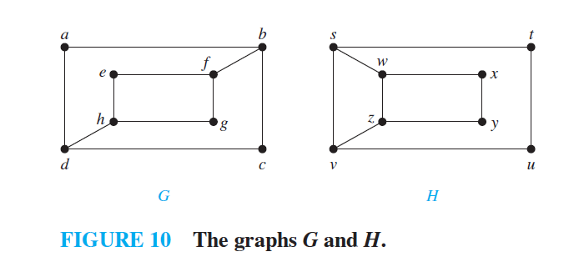

1. Which of the directed graphs in Figure 4 have an Euler circuit? Of those that do not, which have an Euler path? [CO5][E]

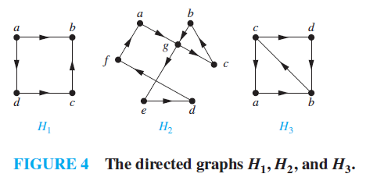

1. Explain about the Dijkstra’s Algorithm. With an example [CO5][U]

20. Find the length of a shortest path between *a* and *z* in the given weighted graph.

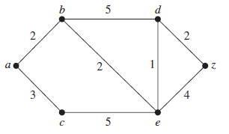

[CO5][E]

21. Explain about the tree traversal. With an example [CO5][U]

22. Determine the Pre-order, In-order, Post-order of the given tree diagram. [CO5][E]

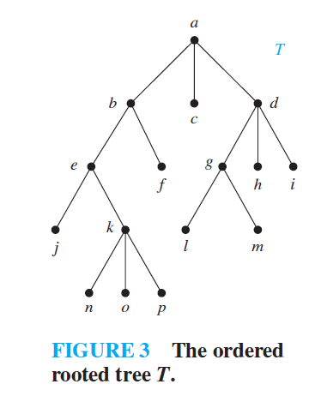

23. Explain about Spanning trees. With an example [CO5][U]

24. Determine a spanning tree of the simple graph *G* shown in Figure 2. [CO5][E]

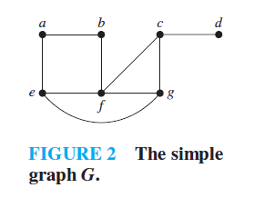

25. Explain about Prim’s algorithm. With an example [CO5] [U]

26. Use Prim’s algorithm, Kruskal’s algorithm to determine a minimum spanning tree in the graph shown in Figure 3. [CO5] [E]

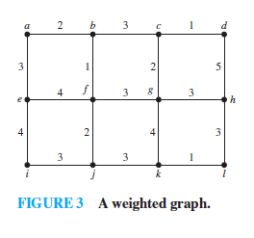

27. Explain about Kruskal’s algorithm. With an example [CO5] [U]

28. Explain about BFS algorithm. With an example [CO5] [U]

29. Explain about DFS algorithm. With an example [CO5] [U]

30. Find the chromatic number of a given graph. [CO5] [U]